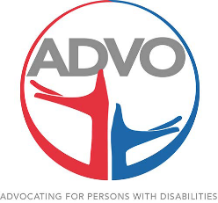
-The Washington Street Journal-
What’s been happening in June??
Man! June has hit, and it’s been a toasty one. The Workshop has had a lot going on this month and we would love to share with everyone! The Amarillo Downtown Library has been inviting the Workshop to go down to the Library, at least once a month for fun activities geared towards our clients. It has been wonderful! In June, we got to make Ice-Cream in a bag, and take home Coloring Books. The Ice-Cream in a bag was just what we needed for all these hot temperatures. The clients measured and combined all the ingredients in a bag filled with Ice, and shook it until it became the consistency of Ice-Cream, then they were able to put all kinds of toppings and chill out (no pun intended) while eating their masterpieces!
The Amarillo College Dental Hygiene class came out and showed the clients how to properly brush their Teeth, how cavities form, and how to avoid them. So to our Nursing Department, we should have 0 cavities from here on out! (LOL) They also brought stuffed animals so our guys could practice getting in between each tooth while flossing and brushing the correct way.
As most of you know, we have 4 of our Special Olympic Athletes who have been given the opportunity to go and compete at Nationals in Seattle, Washington. Mark Schuster, Patti Ballew, and Jessica Ripley will be showing off their muscles and competing in Power Lifting, while Keenon Doss and Carla are combining as unified partners and competing in Bocce! Street VW teamed up with the local authorities to provide an escorted send-off down 45th street for these Athletes. Street VW in Amarillo held a Pep-Rally, and Cook out to wish all of our athletes good luck! GO TEAM TEXAS!
J’Nette had a surprise announcement up her sleeve that is too exciting to keep a secret! Our very own Patti Ballew, will be traveling to Dubai in March of 2019 to represent Team Texas at the Special Olympics’ World Games! Patti is so deserving of this opportunity and will definitely make ADVO and her family proud! We can’t wait to see what all Patti does. CONGRATULATIONS!
WHY the Journal??
I started the Washington Street Journal in hopes to document our exciting adventures we experience daily here at ADVO. I am also hoping this will bring more involvement within our community, and our departments themselves. If you see me with a camera, DON’T be shy, jump on in and smile for the Washington Street Journal. --- Natalie
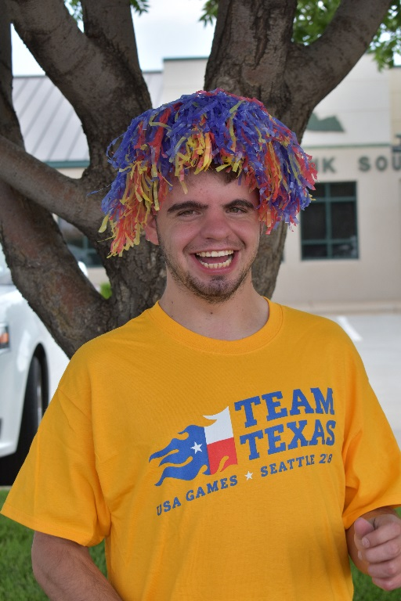
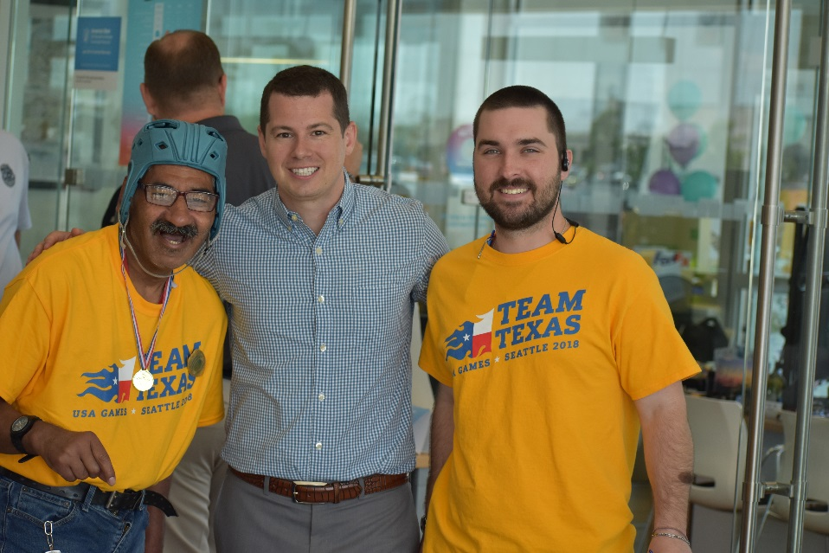
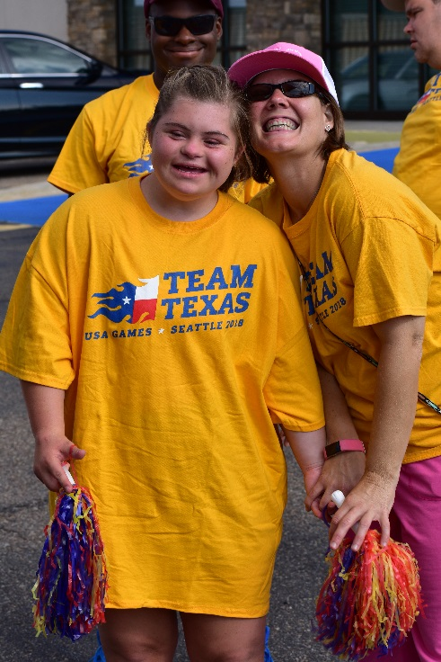
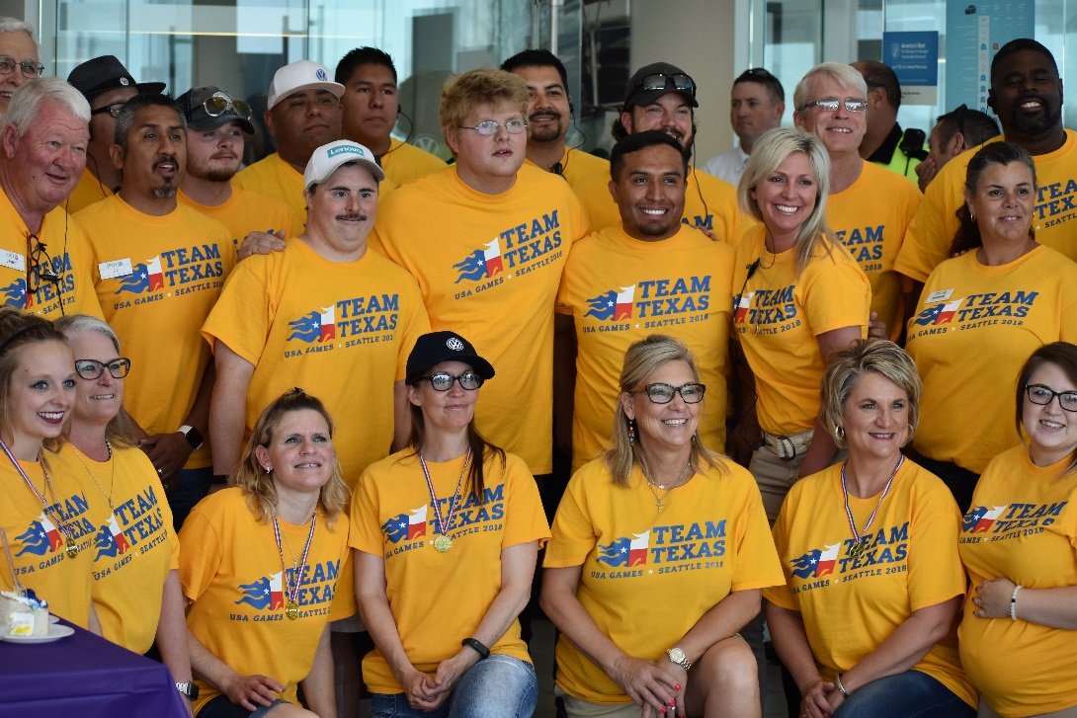
SPECIAL OLYMPICS PEP-RALLY FOR TEAM TEXAS

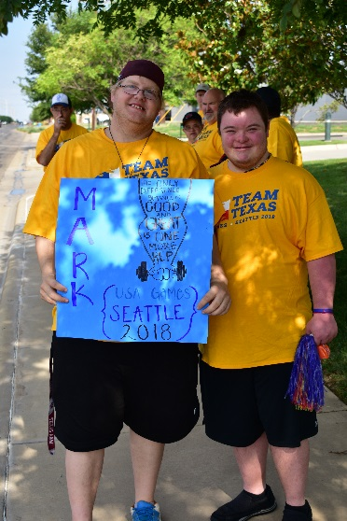
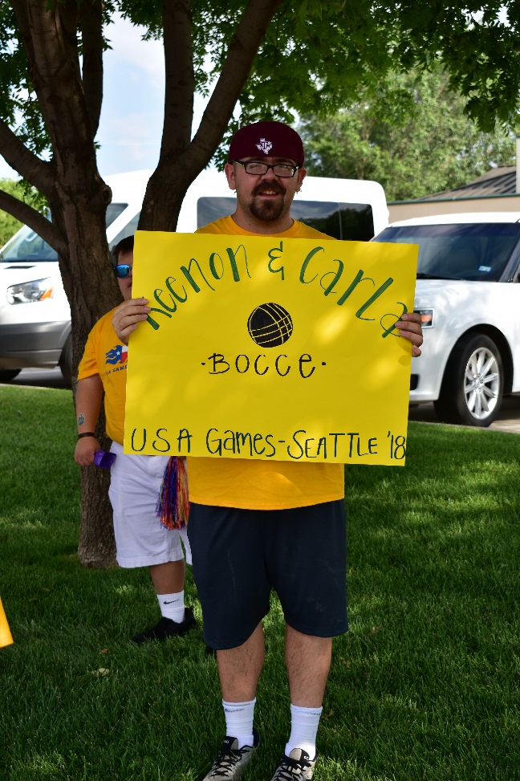
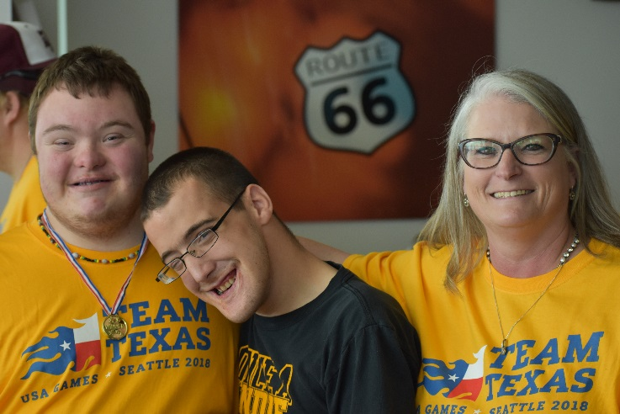
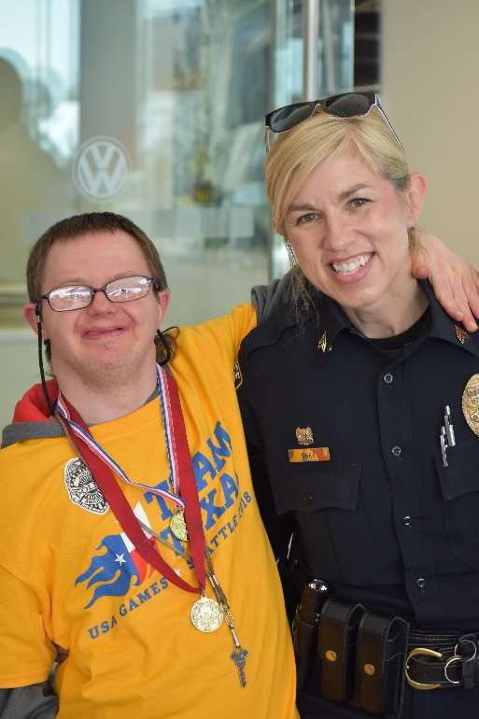
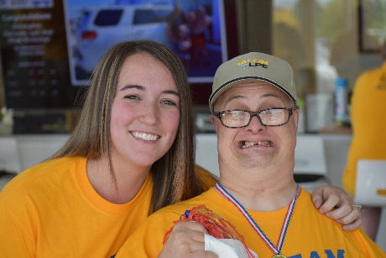
Patti finding out she will be representing Team Texas at the Special Olympics’ World Games in DUBAI!
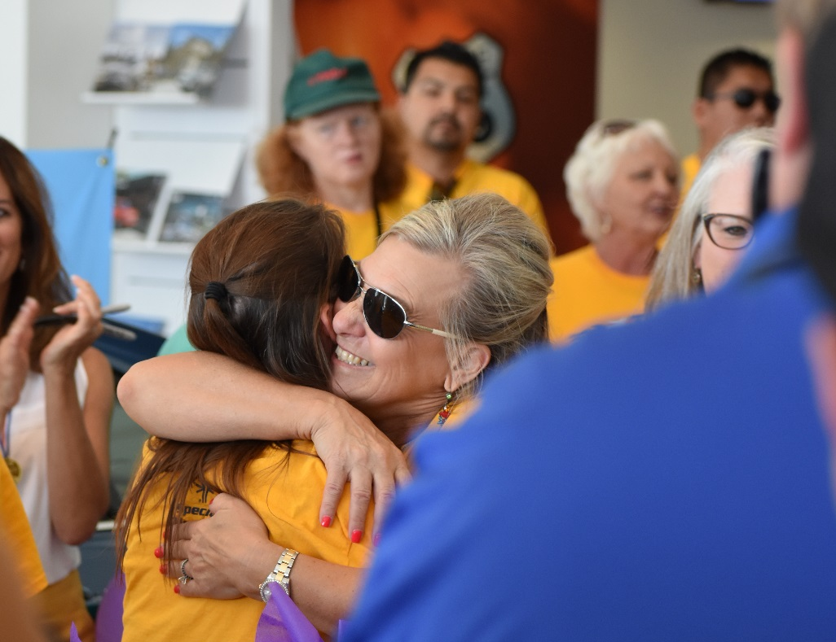
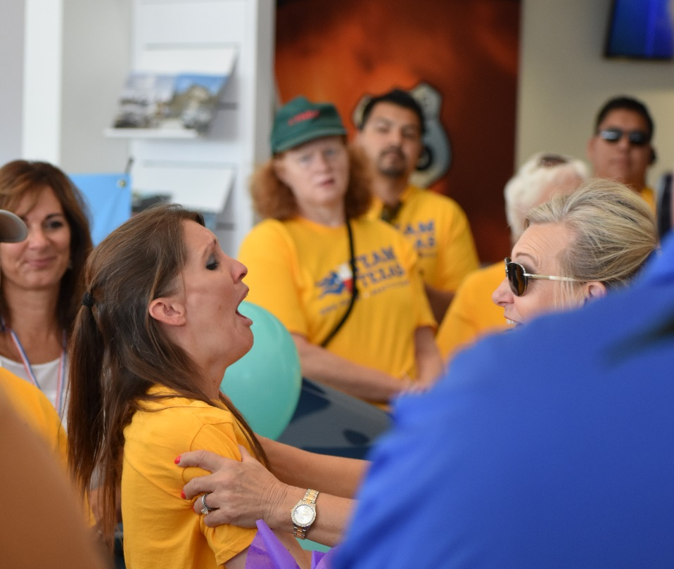

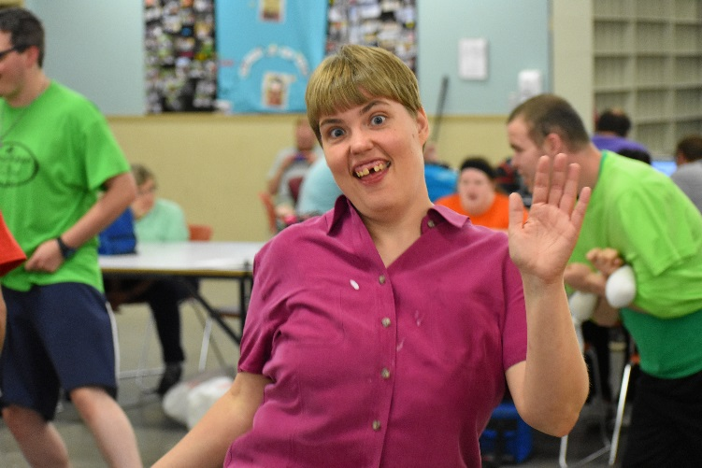
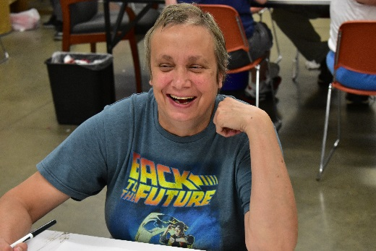
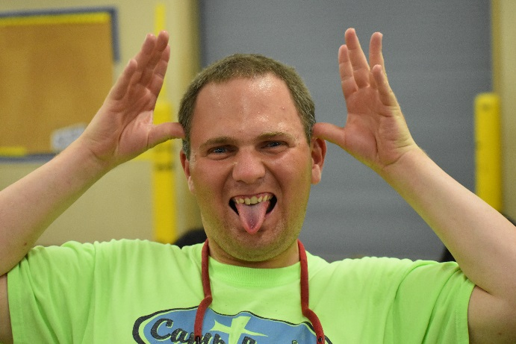
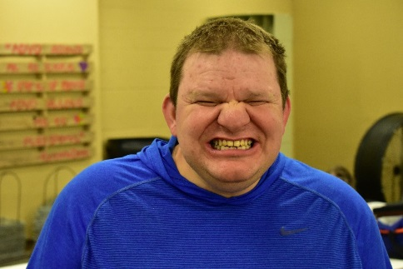
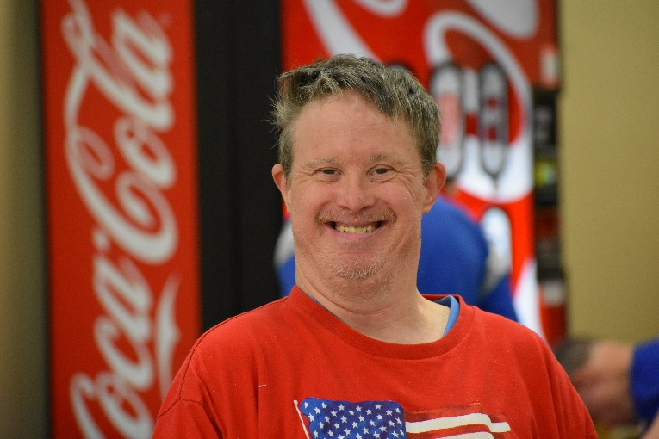
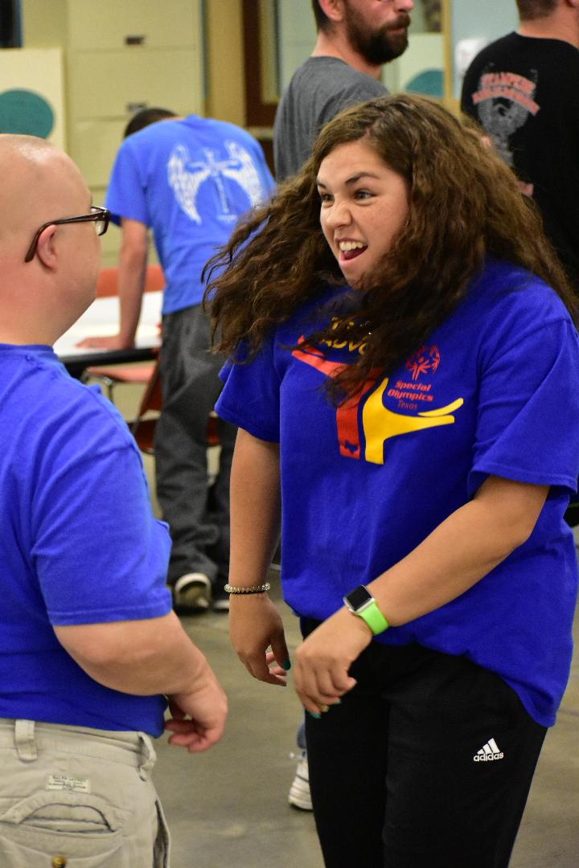
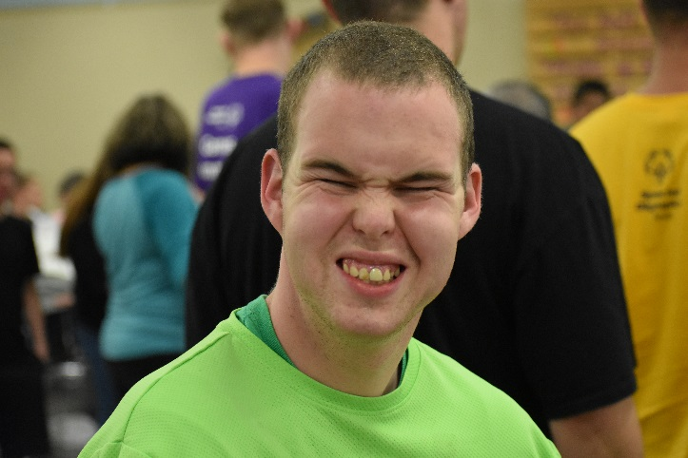
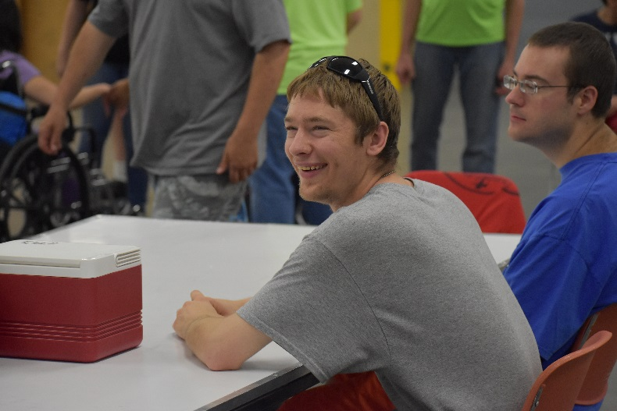
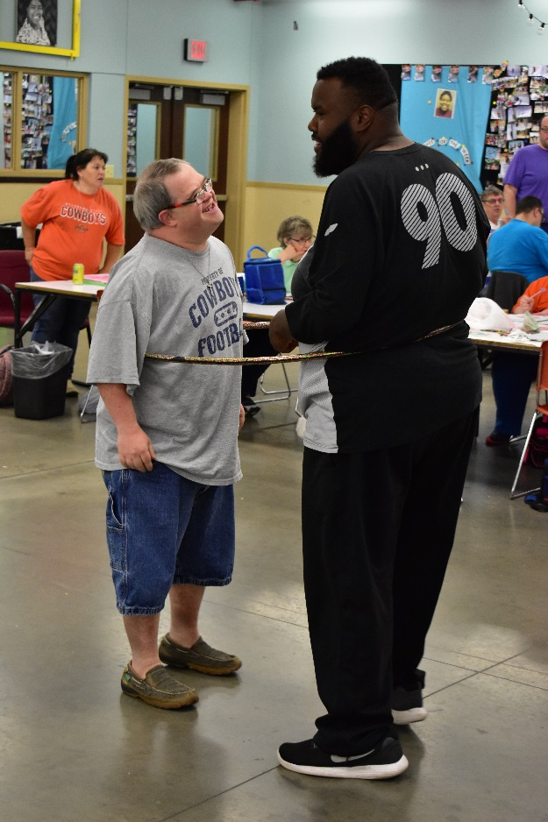
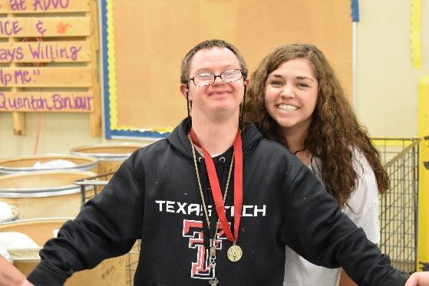
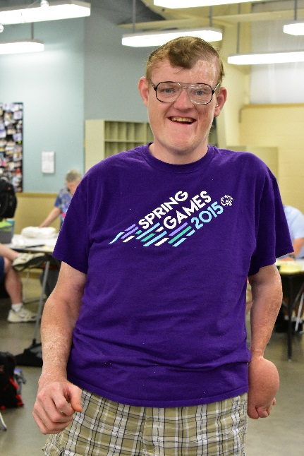
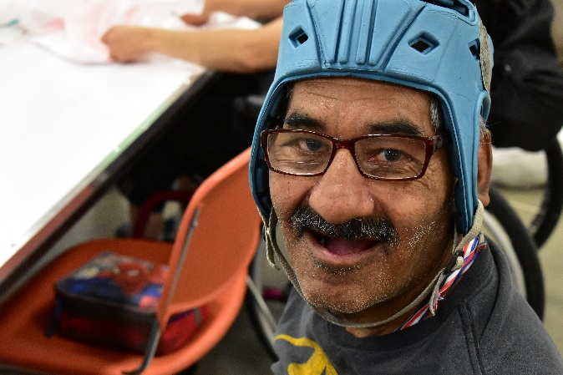
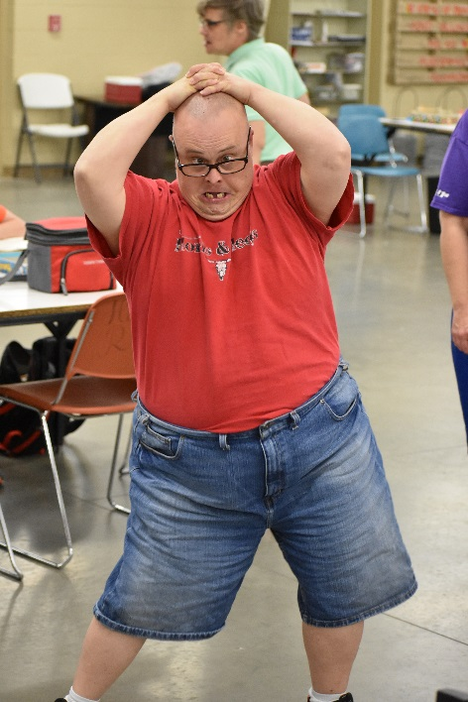
Fun in the workshop
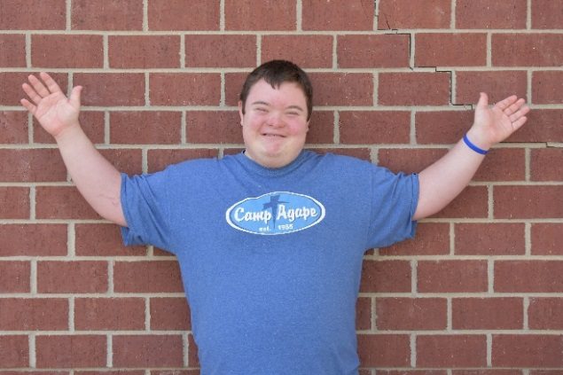
Meet our new clients…
- Andrew O’Sullivan
Lives at the Simpson Home
Favorite Colors: Red and Black
Favorite Food: Cheeseburger’s
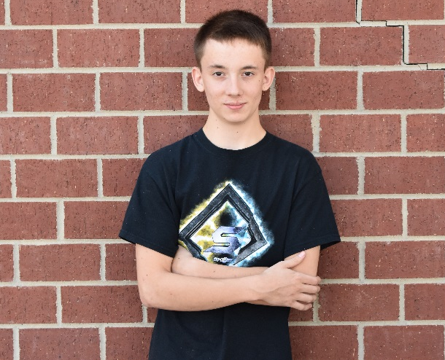

- Ryan Clayton
Attending ADVO for the summer
Favorite Colors: Blue, Green, and Red
Favorite Food: Chocolate Cake

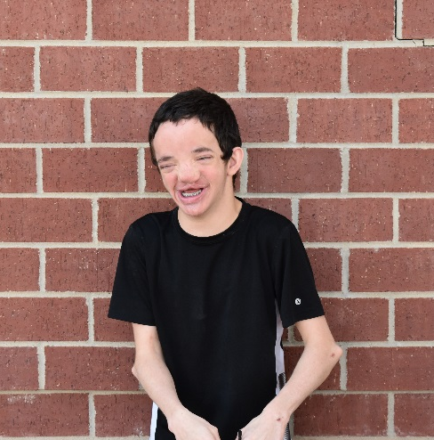
- Dawson Moore
Attending ADVO for the summer
Favorite Color: Blue
Favorite Food: Hot Dogs

- Benjamin Shawcross
Will soon be moving into the Andover House
Favorite Color: Blue
Favorite Food: Lasagna

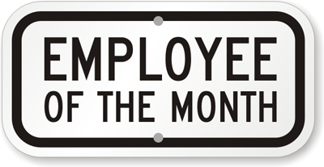
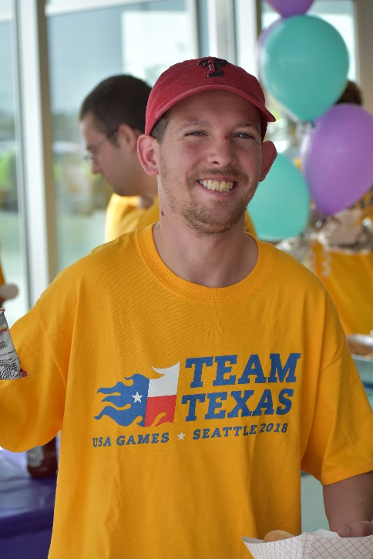

BRETT BLASSINGAME

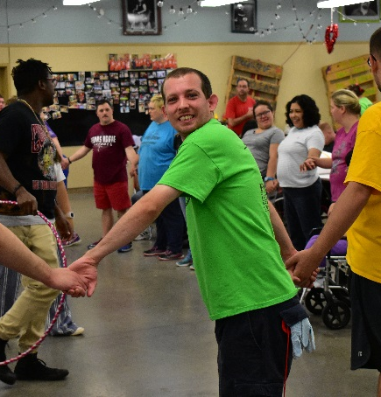
Brett has been chosen for ADVO’s June employee of the month. Brett shows all the qualities that you could ask for in an employee. He always has a smile on his face (as pictured), he never turns down work, and is always open to learning new jobs. Brett works well with almost anyone he is with, and is always cracking a new joke. We are so thankful for Brett being our employee and the qualities he brings to the table.
CONGRATULATIONS BRETT!

